# **Add to MOBILE_SPEC_02_DASHBOARD.md**

## **0. VISUAL PARITY REFERENCE (NEW — top of file, before Page Structure)**

Attach **reference screenshots** and treat them as visual source of truth:

* Dashboard (full scroll)

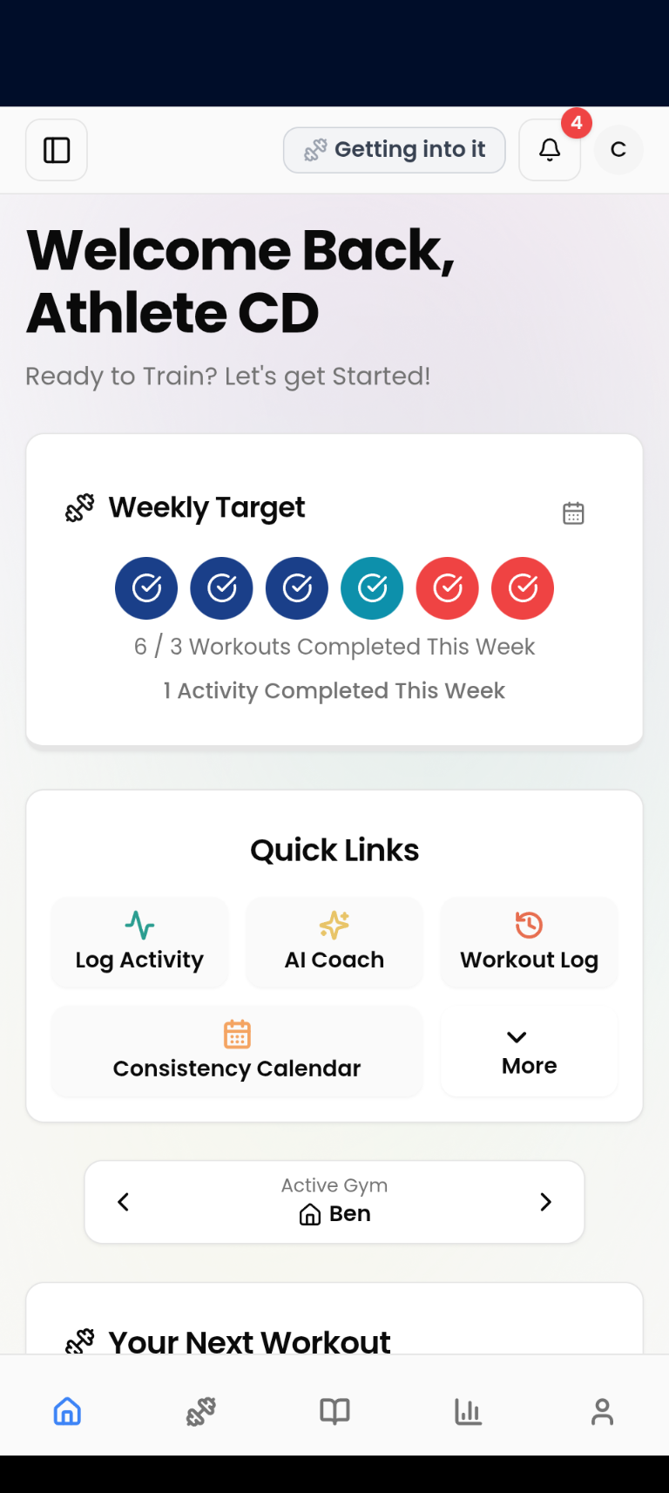

* Previous Workouts “View Summary”

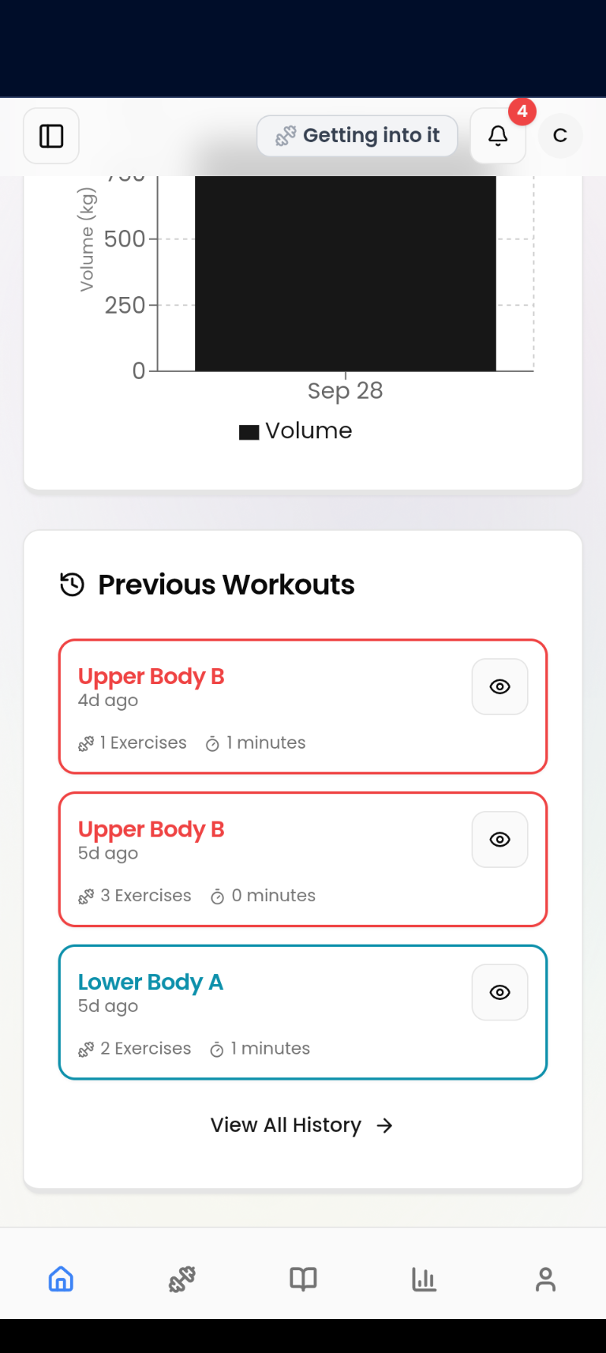

**Acceptance:** Spacing, typography, order, and color application must match **exactly**. Component order to match sections **1.2** and stagger **1.3**.

[MOBILE_SPEC_02_DASHBOARD](https://github.com/HillValleyMustang/WorkoutAppReactN/blob/Main/MOBILE_SPEC_02_DASHBOARD.md)

L14-L23 L24-L33

## **1.4 ROUTING TARGETS (NEW — after Component Order)**

Explicit navigations:

* “Start Workout” → /workout?workoutId={id}
* All Workouts “Play” → /workout?workoutId={id}
* “View All History” → /workout-history
* Quick Links:  
  + Start Workout → /workout
  + Manage Exercises → /manage-exercises
  + Manage T-Paths → /manage-t-paths
  + Profile Settings → /profile?tab=settings&edit=true  
     [MOBILE_SPEC_02_DASHBOARD](https://github.com/HillValleyMustang/WorkoutAppReactN/blob/Main/MOBILE_SPEC_02_DASHBOARD.md)L255-L267 L671-L683 L511-L512

## **1.5 ROLLING STATUS BADGE (NEW — placement reminder)**

Render **immediately below the Welcome Header** on Dashboard and mirror the header badge state; tap opens **Workout Status Explained** modal. (Same states/styles as Layout spec.)

[MOBILE_SPEC_01_LAYOUT_NAVIGATION](https://github.com/HillValleyMustang/WorkoutAppReactN/blob/Main/MOBILE_SPEC_01_LAYOUT_NAVIGATION.md)

L34-L44

## **3.x WEEKLY TARGET — TAP TARGETS & MODAL (AMEND)**

* **Completed circle tap** → opens **Workout Summary Modal** with sessionId.
* **Calendar icon tap** → opens **Consistency Calendar Modal**.  
   Keep circle sizes and color application per workout color system.  
   [MOBILE_SPEC_02_DASHBOARD](https://github.com/HillValleyMustang/WorkoutAppReactN/blob/Main/MOBILE_SPEC_02_DASHBOARD.md)L111-L121 L90-L96 L699-L709

## **6 / 7. NEXT WORKOUT & ALL WORKOUTS — COLOR + ACTIONS (AMEND)**

* Buttons/pills **must use** getWorkoutColor(workoutName) for background/border/text.
* “Start Workout” / “Play” **must navigate** as per 1.4.  
   [MOBILE_SPEC_02_DASHBOARD](https://github.com/HillValleyMustang/WorkoutAppReactN/blob/Main/MOBILE_SPEC_02_DASHBOARD.md)L374-L382 L450-L466 L505-L512

## **9. PREVIOUS WORKOUTS — CARD STYLE GUARANTEES (AMEND)**

* Outer border color = getWorkoutColor(workoutName); “View Summary” opens modal with sessionId. Keep “time ago” formats as specified.  
   [MOBILE_SPEC_02_DASHBOARD](https://github.com/HillValleyMustang/WorkoutAppReactN/blob/Main/MOBILE_SPEC_02_DASHBOARD.md)L618-L636 L651-L655 L643-L651

## **12. PARITY MATRIX — LAYOUT & NAVIGATION (REFERENCE VS RN)**

Verifies header, sheet, tabs, guards, and platform behaviors. Fill **RN Current** during QA.

| **Area** | **Reference Behavior (source)** | **RN Current** | **Parity Requirement (Done when…)** | **QA** |
| --- | --- | --- | --- | --- |
| Top Header — Structure | Sticky/top visibility; safe areas; bg blur on scroll > 50px; 56px height; z-index 30 |  | Height/spacing match; blur threshold & timing exact | ☐ |
| Header Left — Hamburger | 40×40 icon button; opens left sheet; slide-in 300ms |  | Button target ≥44 dp; opens/closes with correct animation | ☐ |
| Header Center — Rolling Status Badge | Pill with 7 states; tap → Status Explained modal; temp success message fade 300ms / 3s / 300ms |  | All states render; modal content complete; animations match | ☐ |
| Header Right — Bell | 40×40 button; unread badge; popover 320px; mark-all-read action; popover scale+fade timings |  | Badge count correct; popover sizes/animations exact | ☐ |
| Header Right — Avatar | 32px circle; initials/photo; dropdown width 224px; Profile/Logout items |  | Avatar fallback works; routes wired to /profile and /login | ☐ |
| Hamburger Menu Sheet | Left side; max-width 360; overlay 60%; grid links; active/inactive states; “Log Activity” button behavior |  | Visual states exact; tapping link navigates + closes sheet | ☐ |
| Bottom Tabs — Items & Order | 5 tabs (Dashboard, Workout, Exercises, Progress, Profile); icons; labels hidden (a11y only) |  | Order/icons correct; screen reader labels present | ☐ |
| Bottom Tabs — Styling | 64px tall; 5 equal columns; 20px icons; active color “action”; 200ms color transition; no page slide on change |  | Heights/gaps exact; transition timing verified | ☐ |
| Workout-Aware Navigation Guard | Intercepts tab & sheet navigation; shows Unsaved Changes dialog; respects WorkoutFlowContext flag |  | Guard triggers on tab press, sheet link, custom nav; dialog copy matches | ☐ |
| Theme & Colors — Utility | Color tokens for base UI; workout colors centralized (use getWorkoutColor) across nav & header elements |  | No stray hexes for workout types; utility used consistently | ☐ |
| Animations & Transitions | Sheet slide 300ms; overlays 200ms; popovers scale/fade 200/150ms; badge loading spinner 1s infinite |  | Timings/easings exact; QA measured in dev tools | ☐ |
| Accessibility | Touch targets ≥44×44; labels for icons/tabs; contrast AA |  | VoiceOver/TalkBack read outs correct; focus order sane | ☐ |
| Safe Areas & Platform | Header/tab respect safe areas; iOS blur + haptics; Android elevation + ripple; back button closes sheet |  | Device tests pass on notch/home-indicator; platform behaviors verified | ☐ |

### **12.1 Navigation Routing Acceptance**

* **Tab presses** replace current tab route with **no slide animation**; 200ms icon/text color transition.
* **Sheet links** push or switch per Expo Router Map (as already defined in your doc).
* **All nav events** pass through the **Unsaved Changes** guard when /workout has active edits.

## **14. WORKOUT COLOR SYSTEM — IMPORT & USAGE (REPLACE HEADER)**

Replace free-floating palette with an **import note**:

Import: import { getWorkoutColor } from "@/lib/workout-colors";

Use in: Weekly Target circles, Next Workout CTA, All Workout pills, Previous Workouts borders/text.

Palette values remain the same as the shared utility to keep parity.

[MOBILE_SPEC_02_DASHBOARD](https://github.com/HillValleyMustang/WorkoutAppReactN/blob/Main/MOBILE_SPEC_02_DASHBOARD.md)

L809-L848

## **19. WORKOUT LAUNCHER (NEW)**

A dedicated screen the Dashboard links to (via “All Workouts”) showing the **program’s workouts as color-coded pills** + an **Ad-Hoc** option.

**Layout**

* Title: “Choose Your Workout”
* Grid: 1 column (mobile)
* Pills: **exact same pill component** as section 7.4; use getWorkoutColor() for border/text/icon.  
   [MOBILE_SPEC_02_DASHBOARD](https://github.com/HillValleyMustang/WorkoutAppReactN/blob/Main/MOBILE_SPEC_02_DASHBOARD.md)L450-L473

**Items**

* PPL: Push / Pull / Legs
* ULUL: Upper A / Lower A / Upper B / Lower B
* Ad-Hoc: distinct color (bonus/ad-hoc mapping)

**Actions**

* Tap a pill → /workout?workoutId={id}
* Ad-Hoc → /workout?adHoc=true

## **20. USER JOURNEYS (NEW)**

Document end-to-end flows so dynamic behavior matches the reference app.

### **Journey A: Completing a Workout**

1. Dashboard → “Start Workout” → /workout?workoutId={id}.  
    [MOBILE_SPEC_02_DASHBOARD](https://github.com/HillValleyMustang/WorkoutAppReactN/blob/Main/MOBILE_SPEC_02_DASHBOARD.md)L371-L373
2. Complete workout → data persisted.
3. Dashboard refresh on return (pull-to-refresh supported).  
    [MOBILE_SPEC_02_DASHBOARD](https://github.com/HillValleyMustang/WorkoutAppReactN/blob/Main/MOBILE_SPEC_02_DASHBOARD.md)L774-L789
4. Effects:  
   * Weekly Target updates circles & counts.
   * Previous Workouts shows new card (top, border color = workout type).  
      [MOBILE_SPEC_02_DASHBOARD](https://github.com/HillValleyMustang/WorkoutAppReactN/blob/Main/MOBILE_SPEC_02_DASHBOARD.md)L614-L621
   * Rolling Status Badge may show temp success message.

### **Journey B: Reviewing a Past Workout**

1. Dashboard → Previous Workouts → **View Summary**.  
    [MOBILE_SPEC_02_DASHBOARD](https://github.com/HillValleyMustang/WorkoutAppReactN/blob/Main/MOBILE_SPEC_02_DASHBOARD.md)L651-L655
2. Workout Summary Modal shows sets/reps/weight/duration.  
    [MOBILE_SPEC_02_DASHBOARD](https://github.com/HillValleyMustang/WorkoutAppReactN/blob/Main/MOBILE_SPEC_02_DASHBOARD.md)L701-L705

### **Journey C: Consistency View**

1. Dashboard → Weekly Target calendar icon **or** Action Hub → Consistency Calendar.  
    [MOBILE_SPEC_02_DASHBOARD](https://github.com/HillValleyMustang/WorkoutAppReactN/blob/Main/MOBILE_SPEC_02_DASHBOARD.md)L90-L96 L239-L245
2. Modal renders color-coded calendar by workout type.  
    [MOBILE_SPEC_02_DASHBOARD](https://github.com/HillValleyMustang/WorkoutAppReactN/blob/Main/MOBILE_SPEC_02_DASHBOARD.md)L706-L709

### **Journey D: Switching Gyms**

1. If user has >1 gym, Gym Toggle is visible; chevrons cycle (wrap).  
    [MOBILE_SPEC_02_DASHBOARD](https://github.com/HillValleyMustang/WorkoutAppReactN/blob/Main/MOBILE_SPEC_02_DASHBOARD.md)L272-L279 L289-L315
2. Dashboard content re-queries for the active gym.

## **21. QA & ACCEPTANCE (NEW)**

**Visual acceptance:** Match screenshots 1:1 (spacing, typography, order, colors).  
 **Functional acceptance:** The following manual tests must pass:

* **Staggered animations**: 0.0s → 0.7s in 0.1s steps.  
   [MOBILE_SPEC_02_DASHBOARD](https://github.com/HillValleyMustang/WorkoutAppReactN/blob/Main/MOBILE_SPEC_02_DASHBOARD.md)L24-L33
* **Pull-to-refresh** reloads *all* sections listed.  
   [MOBILE_SPEC_02_DASHBOARD](https://github.com/HillValleyMustang/WorkoutAppReactN/blob/Main/MOBILE_SPEC_02_DASHBOARD.md)L776-L785
* **Empty/Error states** render as specified per section.  
   [MOBILE_SPEC_02_DASHBOARD](https://github.com/HillValleyMustang/WorkoutAppReactN/blob/Main/MOBILE_SPEC_02_DASHBOARD.md)L383-L407 L684-L696 L876-L895
* **A11y**: 44×44 dp targets; labels for icons; chart alt/summary.  
   [MOBILE_SPEC_02_DASHBOARD](https://github.com/HillValleyMustang/WorkoutAppReactN/blob/Main/MOBILE_SPEC_02_DASHBOARD.md)L899-L911

**Done =** Parity checklist below is 100% ✅.

## **22. PARITY CHECKLIST (NEW — end of file)**

* Welcome Header text rules (Welcome vs Welcome Back) enforced.  
   [MOBILE_SPEC_02_DASHBOARD](https://github.com/HillValleyMustang/WorkoutAppReactN/blob/Main/MOBILE_SPEC_02_DASHBOARD.md)L51-L67
* Component order & stagger timings exactly as listed.  
   [MOBILE_SPEC_02_DASHBOARD](https://github.com/HillValleyMustang/WorkoutAppReactN/blob/Main/MOBILE_SPEC_02_DASHBOARD.md)L14-L33
* Rolling Status Badge placed below header; modal opens.
* Weekly Target: circles colored + tappable; calendar icon opens modal.  
   [MOBILE_SPEC_02_DASHBOARD](https://github.com/HillValleyMustang/WorkoutAppReactN/blob/Main/MOBILE_SPEC_02_DASHBOARD.md)L111-L121 L90-L96
* Action Hub: buttons + destinations wired.  
   [MOBILE_SPEC_02_DASHBOARD](https://github.com/HillValleyMustang/WorkoutAppReactN/blob/Main/MOBILE_SPEC_02_DASHBOARD.md)L206-L267
* Gym Toggle: shows only when userGyms.length > 1; wrap behavior.  
   [MOBILE_SPEC_02_DASHBOARD](https://github.com/HillValleyMustang/WorkoutAppReactN/blob/Main/MOBILE_SPEC_02_DASHBOARD.md)L272-L279 L289-L315
* Next Workout & All Workouts: colors via getWorkoutColor(), navigations correct.  
   [MOBILE_SPEC_02_DASHBOARD](https://github.com/HillValleyMustang/WorkoutAppReactN/blob/Main/MOBILE_SPEC_02_DASHBOARD.md)L374-L382 L505-L512
* Volume Chart renders with config from spec (or native equivalent).  
   [MOBILE_SPEC_02_DASHBOARD](https://github.com/HillValleyMustang/WorkoutAppReactN/blob/Main/MOBILE_SPEC_02_DASHBOARD.md)L521-L571
* Previous Workouts: border/text color by workout, “View Summary” works.  
   [MOBILE_SPEC_02_DASHBOARD](https://github.com/HillValleyMustang/WorkoutAppReactN/blob/Main/MOBILE_SPEC_02_DASHBOARD.md)L618-L636 L651-L655
* Error/Empty/Loading states implemented for all cards.  
   [MOBILE_SPEC_02_DASHBOARD](https://github.com/HillValleyMustang/WorkoutAppReactN/blob/Main/MOBILE_SPEC_02_DASHBOARD.md)L383-L407 L684-L696 L876-L895
* Pull-to-refresh refreshes all dashboard data sources.  
   [MOBILE_SPEC_02_DASHBOARD](https://github.com/HillValleyMustang/WorkoutAppReactN/blob/Main/MOBILE_SPEC_02_DASHBOARD.md)L776-L785
* A11y checks pass (targets, labels, chart alt).  
   [MOBILE_SPEC_02_DASHBOARD](https://github.com/HillValleyMustang/WorkoutAppReactN/blob/Main/MOBILE_SPEC_02_DASHBOARD.md)L899-L911

## **23. PARITY MATRIX — DASHBOARD (REFERENCE VS RN)**

Use this as the single source of truth for visual + functional parity on the Dashboard. Fill the **RN Current** column during QA.

| **Component** | **Reference Behavior (source)** | **RN Current** | **Parity Requirement (Done when…)** | **QA** |
| --- | --- | --- | --- | --- |
| Welcome Header | “Welcome/Welcome Back” logic; name substitution; typography sizes (36 / 14) |  | Implements text rules + sizes; spacing matches screenshot; contrast AA | ☐ |
| Rolling Status Badge (dashboard placement) | Renders immediately under header; tap opens Status Explained modal; mirrors header badge states |  | Same badge component + states; modal opens with full copy; animations match layout spec | ☐ |
| Weekly Target | 3–4 circles (programme PPL/ULUL); completed=filled; incomplete=border with initial; tap completed → workout summary modal; calendar icon opens Consistency Calendar |  | Color via getWorkoutColor(); tap targets 40×40; modal opens with correct sessionId; calendar icon opens modal | ☐ |
| Action Hub (Quick Links) | 6 buttons, 3×2 grid; “Consistency Calendar” spans 2 cols; destinations defined (Start Workout/Manage/AI Coach/etc.) |  | Grid + spacing match; all routes as specified; haptics/ripple present | ☐ |
| Gym Toggle | Shows only if >1 gym; chevrons wrap; centered card; skeleton on load |  | Visibility logic correct; wrap-around verified; data refreshes for new gym | ☐ |
| Next Workout | Title, duration, last workout, CTA button in workout color; navigates to /workout?workoutId={id}; error/empty cases handled |  | Color sourced from getWorkoutColor(); navigation param correct; all states render | ☐ |
| All Workouts | Program title; pills per workout with color border/text; Play button navigates to workout; time-ago formatting |  | Pill component matches spec; time-ago strings correct; navigation works | ☐ |
| Weekly Volume Chart | 250px tall; bars animate from 0; tooltip + legend; empty/error states defined |  | Animation & tooltip wired; empty/error cards render; responsive container works | ☐ |
| Previous Workouts | Show last 3; border color by workout; “View Summary” opens modal; exercise count + duration; “View All History” button |  | Border/text use getWorkoutColor(); modal gets sessionId; view-all routes correctly | ☐ |
| Pull-to-Refresh | Refreshes **all** dashboard data sources (summary, T-Paths, gyms, chart, history) |  | Single pull refreshes every widget; spinner lifecycle correct | ☐ |
| Component Order + Stagger | Order: header→weekly target→…→previous workouts; stagger 0.0–0.7s (100ms steps) |  | Order exact; animation timings exact; easing matches | ☐ |
| Error/Empty/Loading | Per-section states implemented verbatim (weekly target, next/all workouts, chart, previous) |  | Every state reachable in dev tools; copy/visuals match | ☐ |
| Accessibility | 44×44 targets; labels for icons/buttons; chart alternative/summary text |  | All elements labelled; TalkBack/VoiceOver pass | ☐ |
| Color System | Colors come from single utility; mapping covers PPL + ULUL; applies to all colored UI |  | getWorkoutColor() used; no stray hex codes | ☐ |

### **23.1 Dashboard Test Scenarios**

* **Happy path:** Start + finish a workout → Dashboard updates Weekly Target, Previous Workouts, Rolling Badge.
* **No active gym / no T-Path:** Verify message + links.
* **ULUL vs PPL:** Circle count and labels change accordingly.
* **Error injection:** Force fetch failure per widget; confirm error UIs.